Description on how to download Forex and World Index data from INO.com Exchanges:

This document describes the setup and process
- to get updated Forex and World Index ticker lists (.tic files) every time you do a last-trade download (daily data)
- to get last-trade data
- to get historical daily data

Last-trade data and symbols are downloaded from:
Foreign Exchange (FOREX)
http://quotes.ino.com/exchanges/exchange.html?e=FOREX

World Indices
http://quotes.ino.com/exchanges/exchange.html?e=WORLD

Set-Up for Symbol Refresh and Last-Trade Data Download:

- Copy the following line and append to your existing “mywebserver.txt”, or simply substitute it the attached “mywebserver.txt”.

INO_XXXX,http://quotes.ino.com/exchanges/exchange.html?e=XXXX,L3,Futures_INO_L3.fmt

- Place the “Futures_INO_L3.fmt” file in the “fmt” subfolder.
- Run HSQuote Plus and set up the screen as soon. Please note that the portfolio name should be “INO_FOREX.tic” and “INO_WORLD.tic.
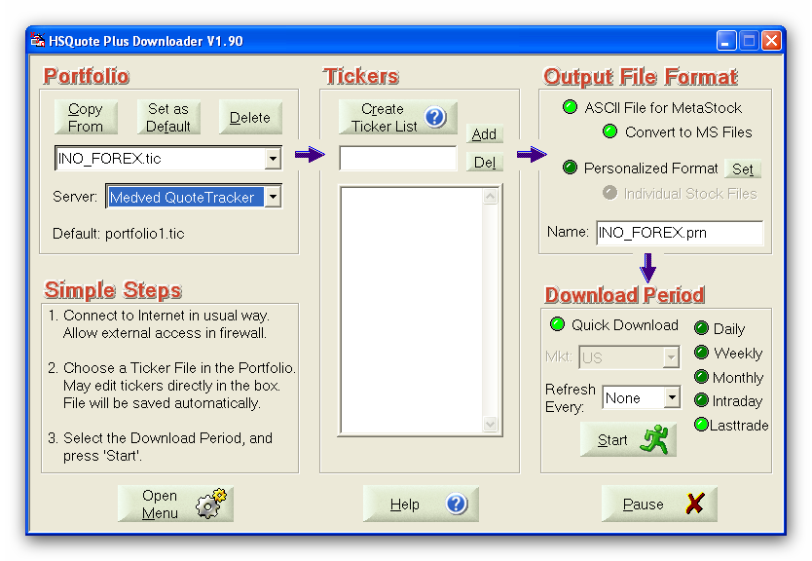

Note that in the Tickers List, we do NOT need to enter all the symbols on the web page http://quotes.ino.com/exchanges/exchange.html?e=FOREX
as shown below. The trick is that in the “Futures_INO_L3.fmt” file, we have added a line:
1@myRenewTickers#Renew Ticker List before download (default: 0, No)
This line tells the program to always renew the ticker list before downloading new data. Of course, you may choose to manually enter the symbols and delete this line ☺.

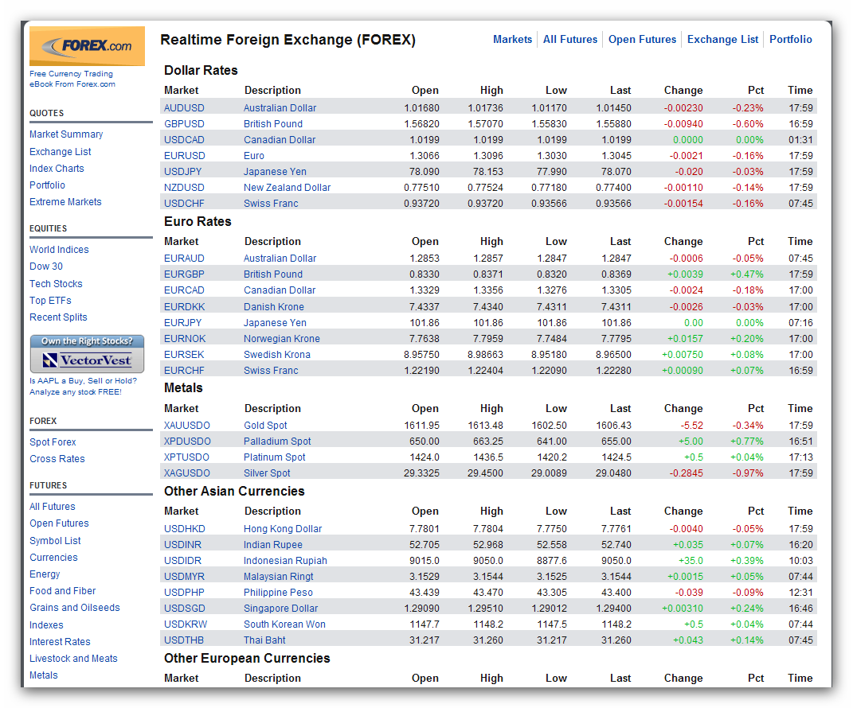

Last-Trade Daily Data Download:

This web page refreshes the last-trade data regularly. You may download in the middle of the session or at the end of the day. Please note that the data will carry the date that the download is done. So you need to do the download on the same day. You may set up the Microsoft Task Scheduler to download data on a fixed schedule.

Set-Up for Historical Data Download – Daily Data:

- Copy the following line and append to your existing “mywebserver.txt”, or simply substitute it the attached “mywebserver.txt”.

INO_XXXX,http://club.ino.com/quotes/data/?q=1&ticket=marketclubref&s=SSSS&w=d&f=csv,D1,Futures_INO_DI1.fmt

- Copy the “Futures_INO_DI1.fmt” file to the “fmt” subfolder.
- Run HSQuote Plus and call up the ‘INO_FOREX.tic’ or ‘INO_WORLD.tic’ portfolio as shown.

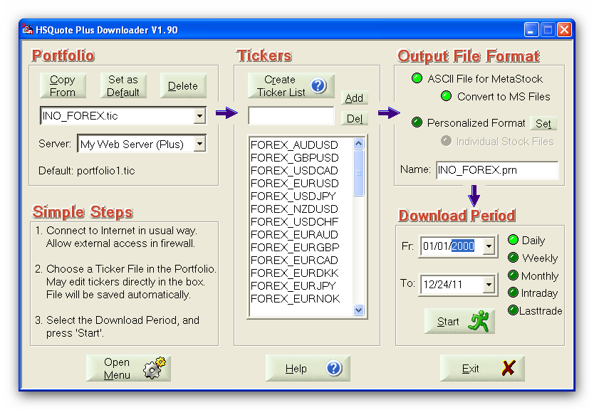

Historical Daily Data Download:

As the last-trade daily data download can automatically download symbols. You want to run historical daily data AFTER the last-trade daily data has been downloaded.

For the first time, you may set the Fr date as far back as 01/01/2001. That is all you need to do before “Start” to collect historical data.

